**Lab 6 – High Power Control**

Austin Huang and Matthew Rodriguez

**Figures**

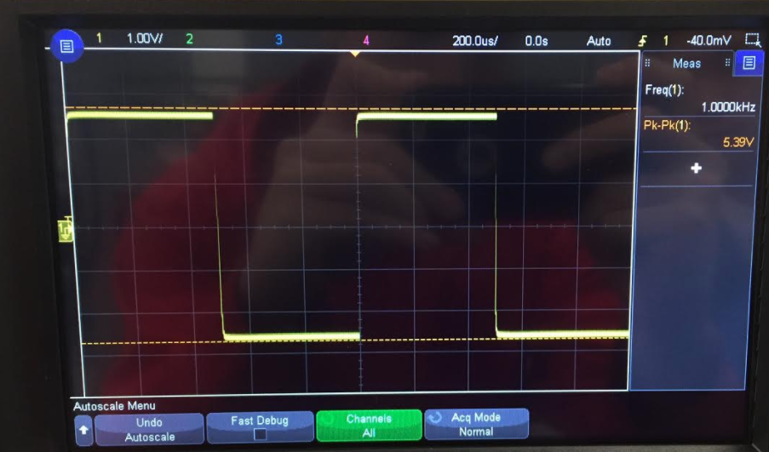

Figure 1: Measured output of circuit with 1Hz square wave on gate of MOSFET

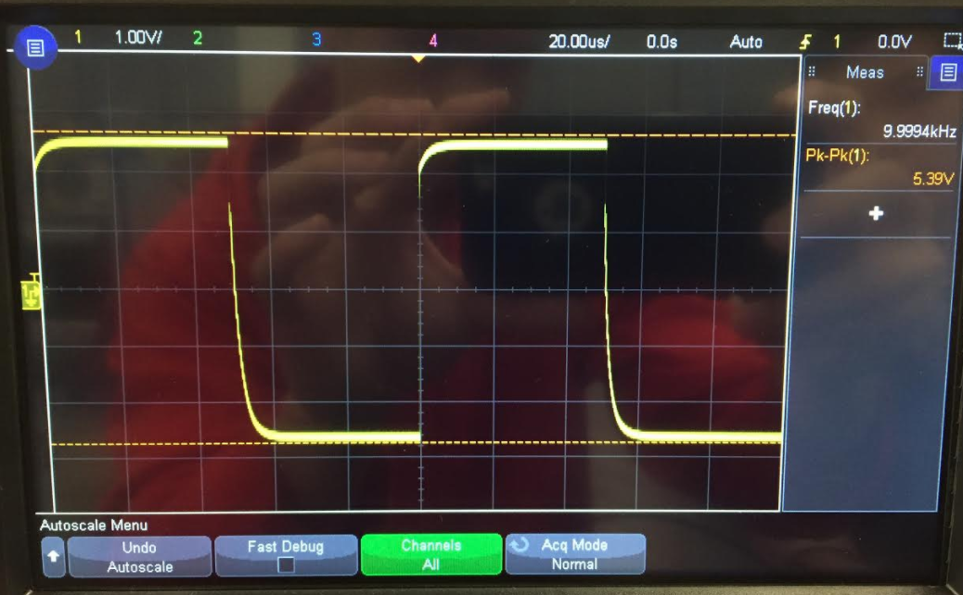

Figure 2: Measured output of circuit with 10kHz square wave on gate of MOSFET

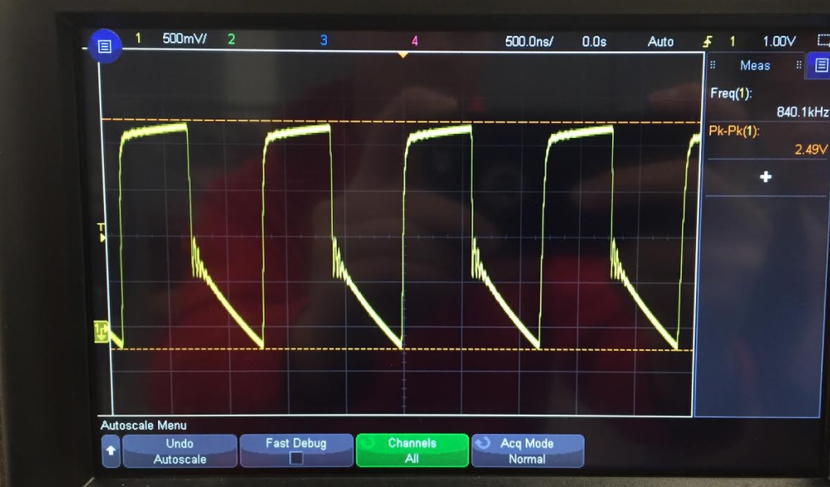

Figure 3: Measured output of circuit with 840kHz square wave on gate of MOSFET

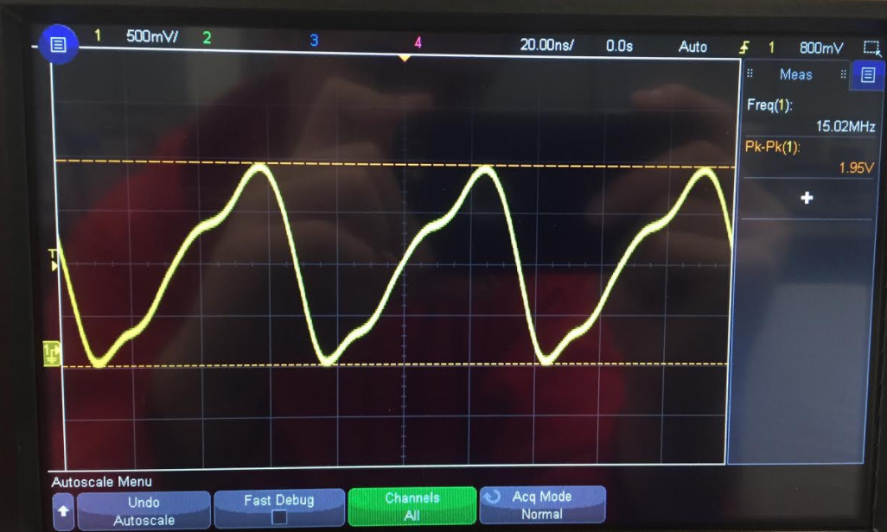

Figure 4: Measured output of circuit with 15MHz square wave on gate of MOSFET

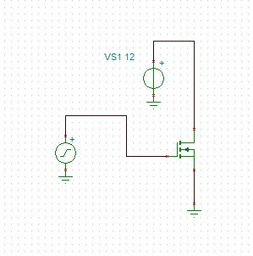

Figure 5: Tina-Ti schematic of MOSFET circuit

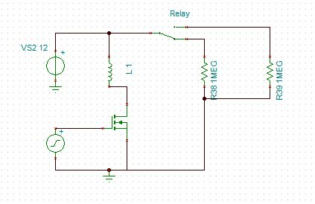

Figure 6: Tina-Ti schematic of relay circuit

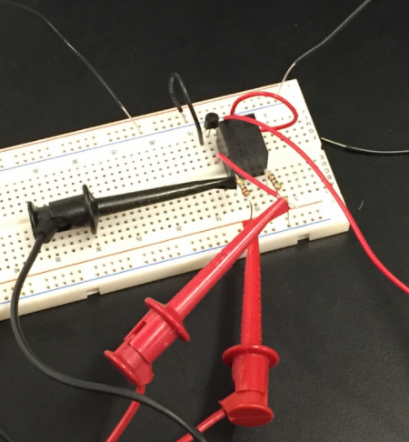

Figure 7: Relay circuit built based on Tina-Ti schematic

**MOSFET switch**

The MOSFET switch is a very simple circuit which can be used in a multitude of applications. One of the most important features of the MOSFET Switch is the near zero current it takes to switch the MOSFET from an on to an off state. There are two main architectures, low-side and high-side switch, each requiring a different type of MOSFET.

A simple circuit was built and tested to observe the functionality of the MOSFET. The MOSFET was used to handle a PWM wave from the MSP430 to power a fan. The circuit schematic built in Tina-Ti can be seen in Figure 5.

The circuit was tested again with an input from the wave form generator instead of the MSP430. This would allow for free and easy adjustment of the input frequency to test the switching speed of the MOSFET. The waveform generator was set to a 5VPP square wave starting at 1kHz the output is seen in Figure 1. The frequency was raised until “weird behavior” occurred which determined the limitation of the switching speed of the MOSFET. The MOSFET’s switching speed was found to be limited to a frequency of 10kHz as seen in Figure 2. The 10kHz signal can be seen to start slightly deviating from a clean square wave (1kHz signal) as seen in Figure 1. The frequency was cranked up even higher to see how distorted the output wave would become. At 840kHz in Figure 3, The output voltage wave is seen to start looking very distorted. Out of curiosity, the frequency was then turned to a max of 15MHz, and the output is seen in Figure 4.

**Relays**

A relay is an electro-mechanical system which can open and close a switch based on an input. These are extremely useful in situations where large amounts of current need to flow, such as in automotive applications, but they do have their limits. For starters, since the actuation process requires a constant current, sometimes this can be too much for a processor to handle.

The relay essentially acts as a mechanical switch. Upon studying the pin out of the relay, a circuit was built to test the functionality and limitations of a relay. The schematic built in Tina-Ti can be seen in Figure 6. The actual circuit built can be seen in Figure 7. By using a constant 12V DC signal across the coil of the relay and a 12V DC input, a fan was powered. The relay acted as a switch, where the electromagnetic field generated by coil pulled up the switch causing a connection to be made allowing the fan to receive the voltage required to turn on.

Similarly, the circuit was tested with an AC signal across the coil as well. The relay was expected to switch back and forth between the normally open and normally closed pins allowing for the fan to be powered by a voltage mimicking a PWM signal. The results are confirmed in the attached video labeled “FanRelay” to this repository. The relay’s switching mechanic is quite audible as the connection is made to power the fan. Clicks in rapid succession are heard as the switch goes back and forth. The fan was successfully powered as seen in the video.

The circuit was tested again with an input from the wave form generator instead of the MSP430. This would allow for free and easy adjustment of the input frequency to test the limitations of the relay. Initially, the waveform generator input was set to 1Hz. This would allow for testing of the mechanical device at a frequency where it should perform properly. The audible clicks of the switching back and forth meant that it was working properly. The video with audio is attached in the repository. (Video labeled “RelayWorkingAt1Hz”) Since it is a mechanical device, it is not expected to handle very high frequencies. The frequency of the AC signal across the coil was increased until a breaking point or cut-off frequency for the device was found. The breaking point was defined to be dependent on its audible reactions to the increased frequency as well as the voltage output recorded by the oscilloscope. Once the relay was observed to be failing from audio cues, the oscilloscope was used to measure the output of the circuit. The wave output eventually “broke”, where the wave shape dramatically changes, as seen in the video labeled “RelayBreaking” attached in the repository. The cut-off frequency was then recorded. The result was estimated to be around the 394 Hz range.